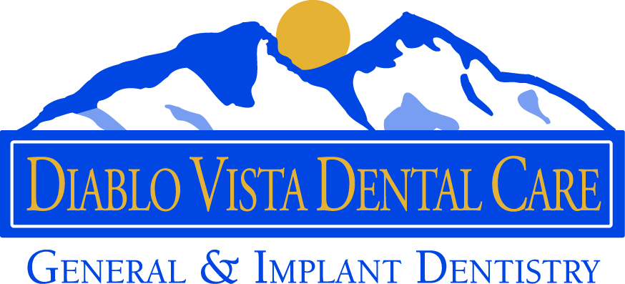

INFORMED CONSENT FOR THE EXTRACTION OF TEETH

Extraction of teeth is an irreversible process and, whether routine or difficult, is a surgical procedure. As in any surgery, there are some risks. They include, but are not limited to the following:

- Swelling and/or bruising and discomfort in the surgery area.
- Stretching of the corners of the mouth resulting in cracking and bruising.
- Possible infection requiring additional treatment.
- Dry Socket – jaw pain beginning a few days after surgery, usually requiring additional treatment. It is most common in lower teeth extraction and the removal of wisdom teeth.
- Possible damage to adjacent teeth, especially those with large filling and crowns.
- Numbness or altered sensation in the teeth, gums, lip, tongue and chin, due to the closeness of roots (especially wisdom teeth) to the nerves which can be bruised or damaged.
- Trismus- limited jaw opening due to inflammation or swelling. Sometimes it is a result or jaw joint discomfort (TMJ), most common after the removal or wisdom teeth.
- Bleeding-significant bleeding is not common, but persistent oozing can be expected for several hours.
- Sharp edges or bone splinters may form later at the edge of the socket. These usually require additional care to smooth or remove.
- Incomplete removal of tooth fragments-to avoid injury to vital structures such as nerves or sinus, sometimes small root tips may be left in place.
- Sinus involvement-the roots of upper teeth can be close to the sinus and sometimes a piece of root can be displaced in to the sinus or an opening may occur into the mouth which may require additional treatment.
- Jaw fracture- while quite rare, it is possible in difficult or deeply impacted teeth.

Most procedures are very routine and serious complications are not expected. Those which can occur are most often minor and can be treated.

The dental care and treatment to be performed has been explained to me, and I understand what is to be done and that there is no warranty or guarantee as to any result and/or cure. I may ask Dr. Fard for a more complete explanation.

This is my consent for the extraction, anesthetics and x-rays to be taken.

I have read and understand the above and give me consent to surgery.

